**Airbnb Data Visualization using Microsoft Power BI**

**Final Group Project**

Divya Tirumala (Z1907811)

Gouri Patil (Z1931431)

Department of Operations and Management Information Systems

Northern Illinois University

OMIS 661 Business Intelligence Tools and Applications

Dr. Chang Liu

May 8, 2023

**Contents**

1. Executive Summary
2. Data Cleaning and Shaping
3. Data Modeling
4. Data Analysis & Visualization
5. Dashboard Design
6. Data Patterns & Recommendations

**Executive Summary**

Airbnb is one of the business models operating online for renting or leasing a property for short-term homestays. The dataset includes information related to listings, including host, Properties, Availability, neighborhoods, and reviews. We chose the data listings of Chicago based on the data till March 2023. We also have data for the calendar year 2023-2024 to know how likely the future prices will be. We use Microsoft Excel and Microsoft Power BI to clean, shape and visualize the data. The project's objective is to analyze and visualize the listings of Chicago. To understand the performance of listing prices, the pattern of bookings and availability, behavior pattern of hosts and guests, and to review and feedback analysis.

**Data Cleaning and Shaping**

The data source for this project is <http://insideairbnb.com/get-the-data/>. There are 7748 listings on Airbnb Chicago. The unit of analysis is Airbnb listing in Chicago. In data cleaning, we selected the required fields and loaded data from Excel into Power BI. We removed "N/A" and blank rows and replaced them with null values. We also replaced the special characters in the comments section of customer reviews and filtered records based on the required dates. We split the column using a delimiter and created new columns for the city and state. Removed irrelevant columns and renamed the existing columns accordingly. Created a hierarchy for the date column and added another column to get the day and week.

**Data Modeling**

There is one fact table and 5-dimension tables for the data modeling part, as shown in the diagram below. We implemented a snowflake schema for modeling the data. The listings table is the fact table and contains data related to each Airbnb listing in Chicago, its price, reviews, and ids of other dimension attributes. ListingPropertyDetails contain information related to each listing property, such as its URL, property type, category, image, number of beds, bath, etc. It is having 1:1 relationship with the fact table. The host table contains details about the host, such as hostname, neighborhoods, picture, URL, etc. It is having 1:M relationship with the fact table. Review Details contains information regarding the reviews of the listing, and it is having 1:M relationship with the fact table. The Review Score table contains information regarding the scores for listing location, cleanliness, check-in, etc. It has a 1:1 relationship with the ListingPropertyDetails table.

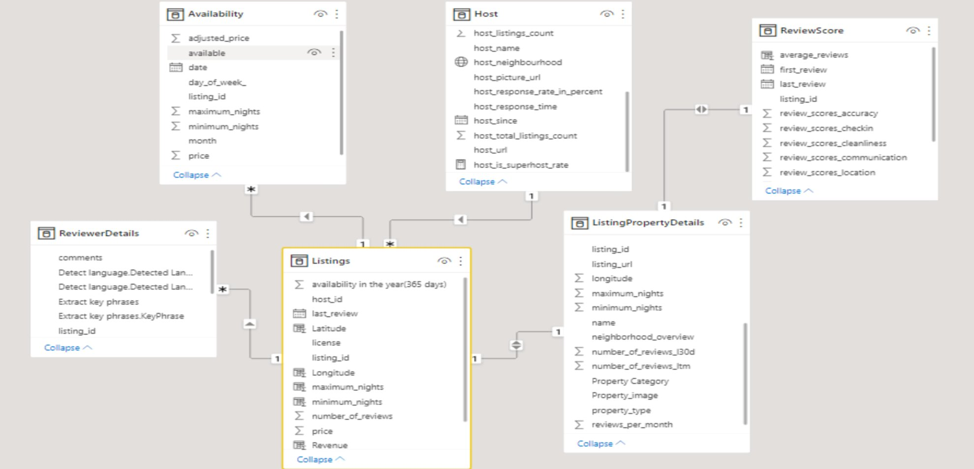

**Data Analysis and Visualization**

We analyzed the data based on price, reviews, availability, host response, property, and listings. We visualized them using bar charts, pie charts, gauge charts, word clouds, decomposition trees, key influencers, area charts, and donut charts.

**Price Analysis**

We analyzed the pricing details of each neighborhood based on property category, number of bedrooms, property type, room type, and the amenities provided by the listings.

**Price by Neighborhood**

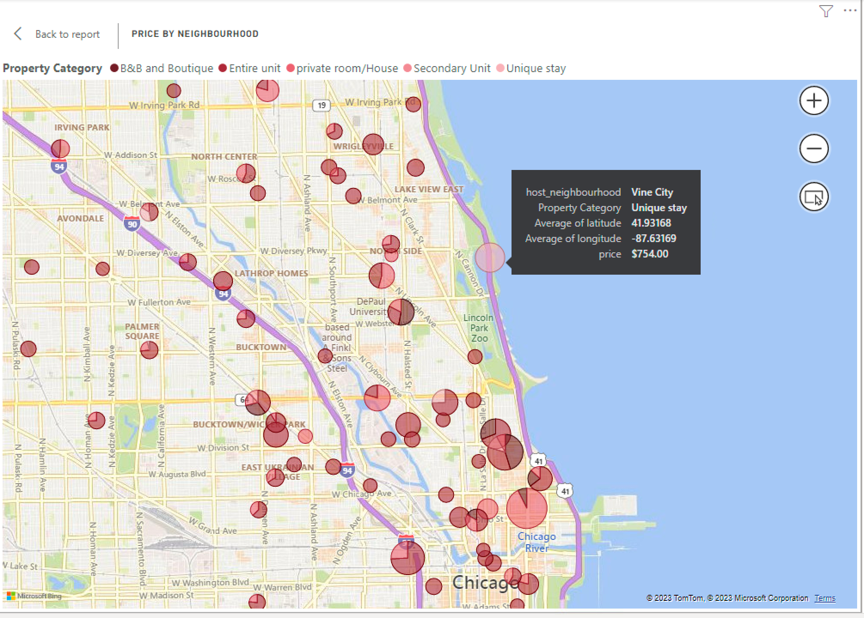

**Price by bedrooms**

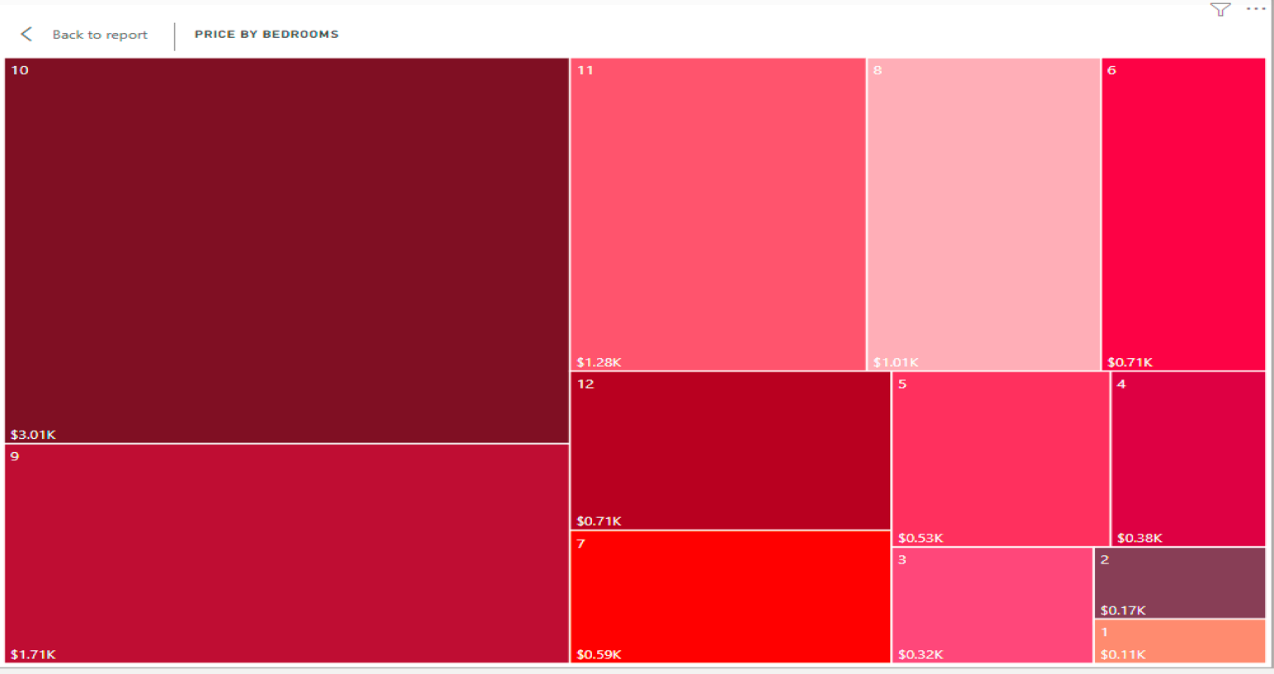**Price by amenities**

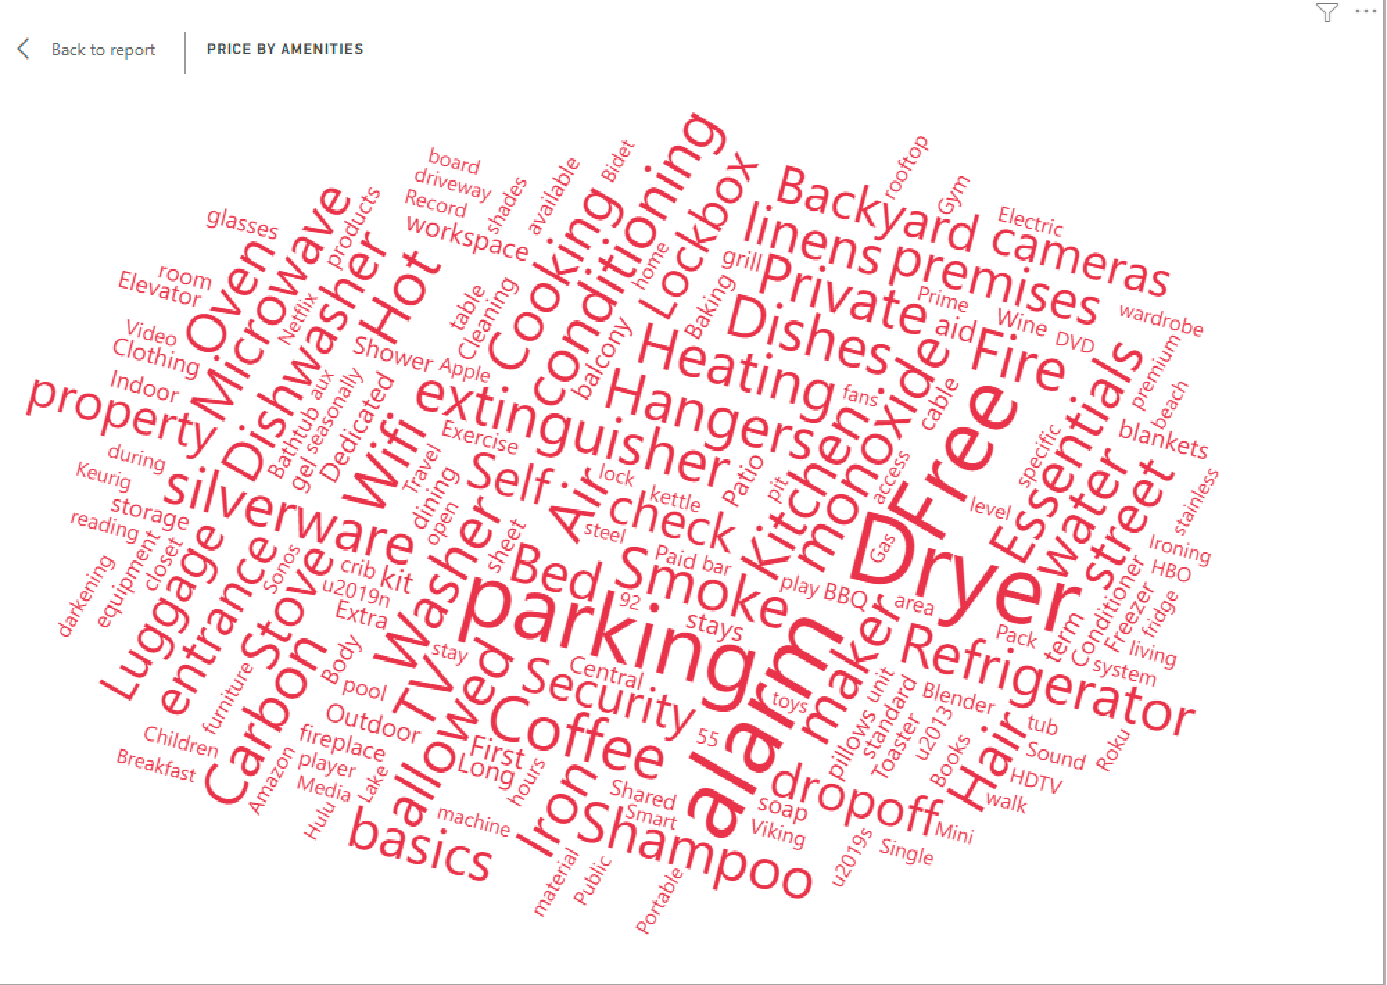

**Price by room type**

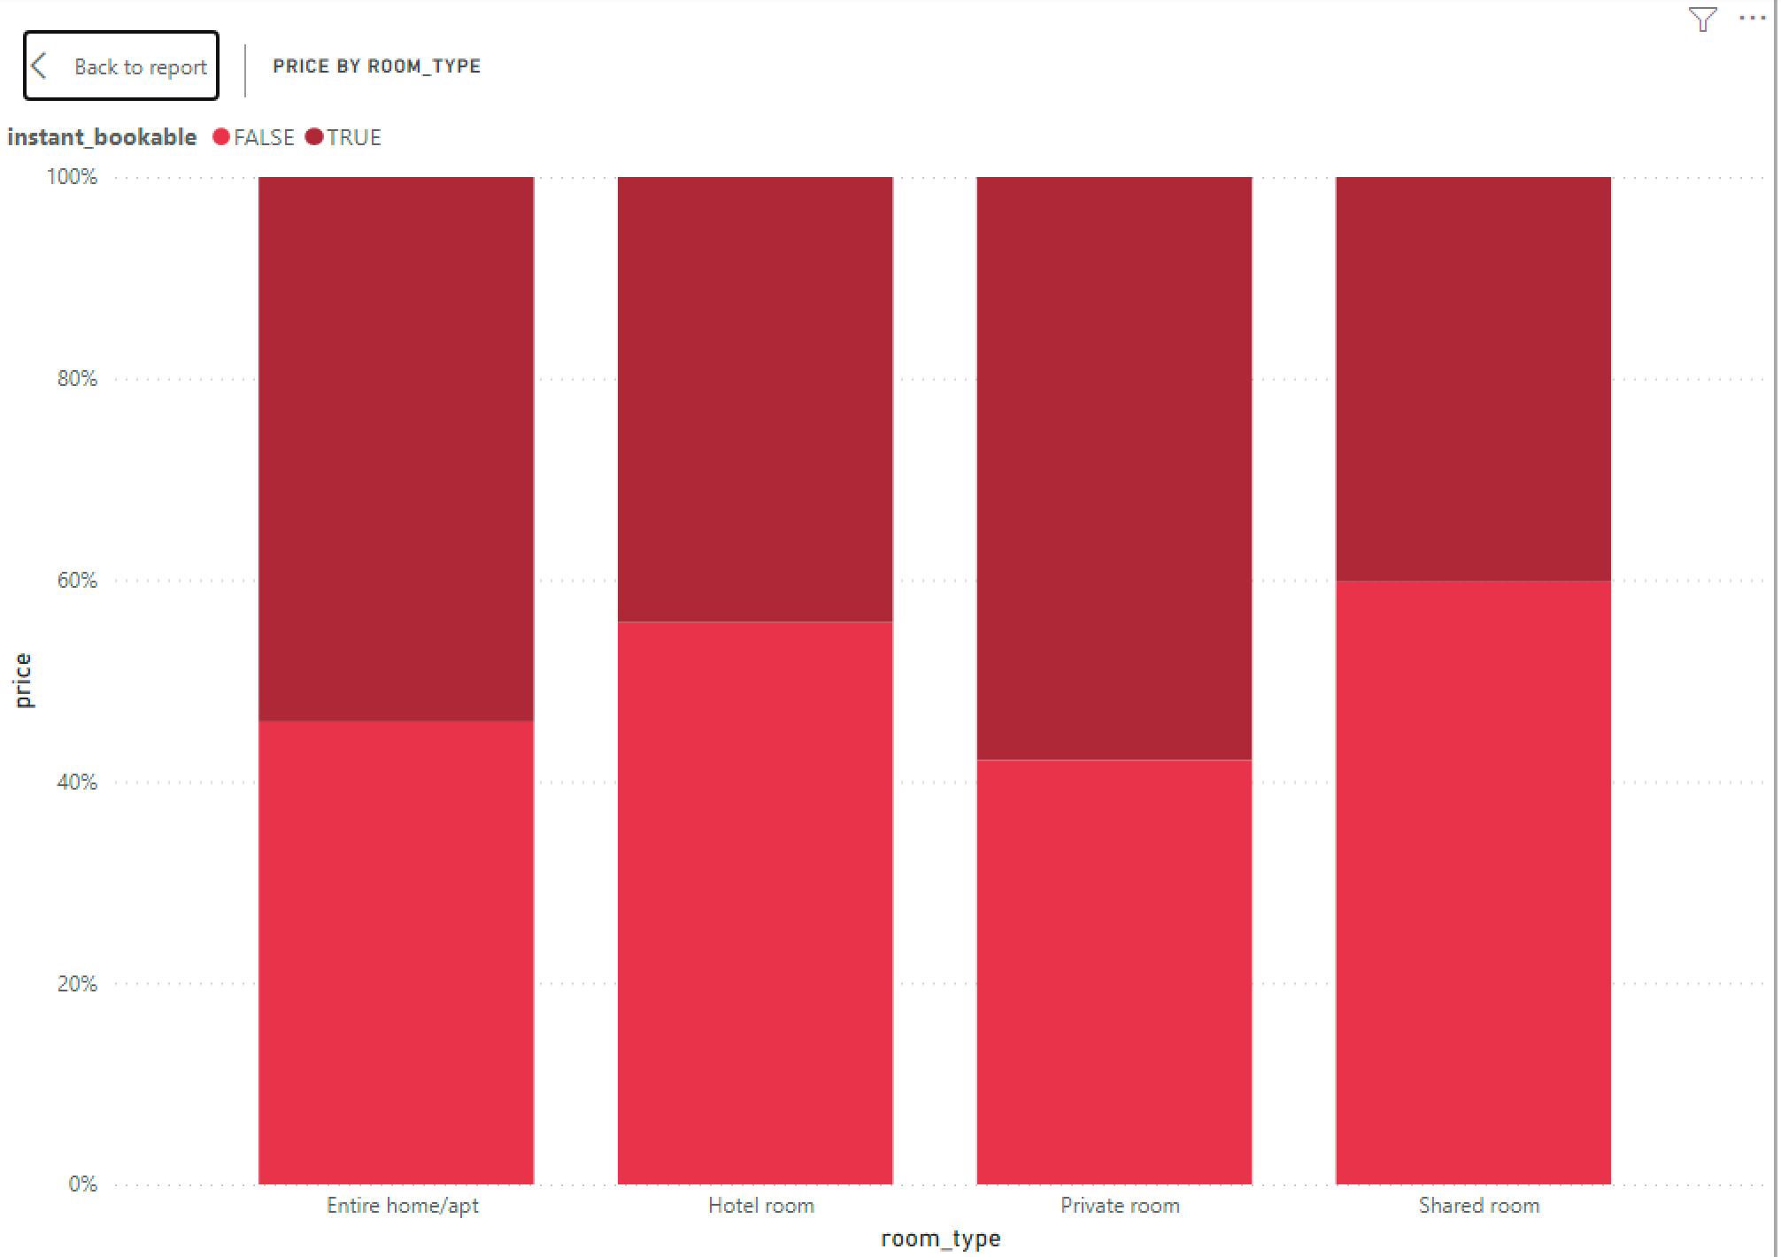

**Price by Property type**

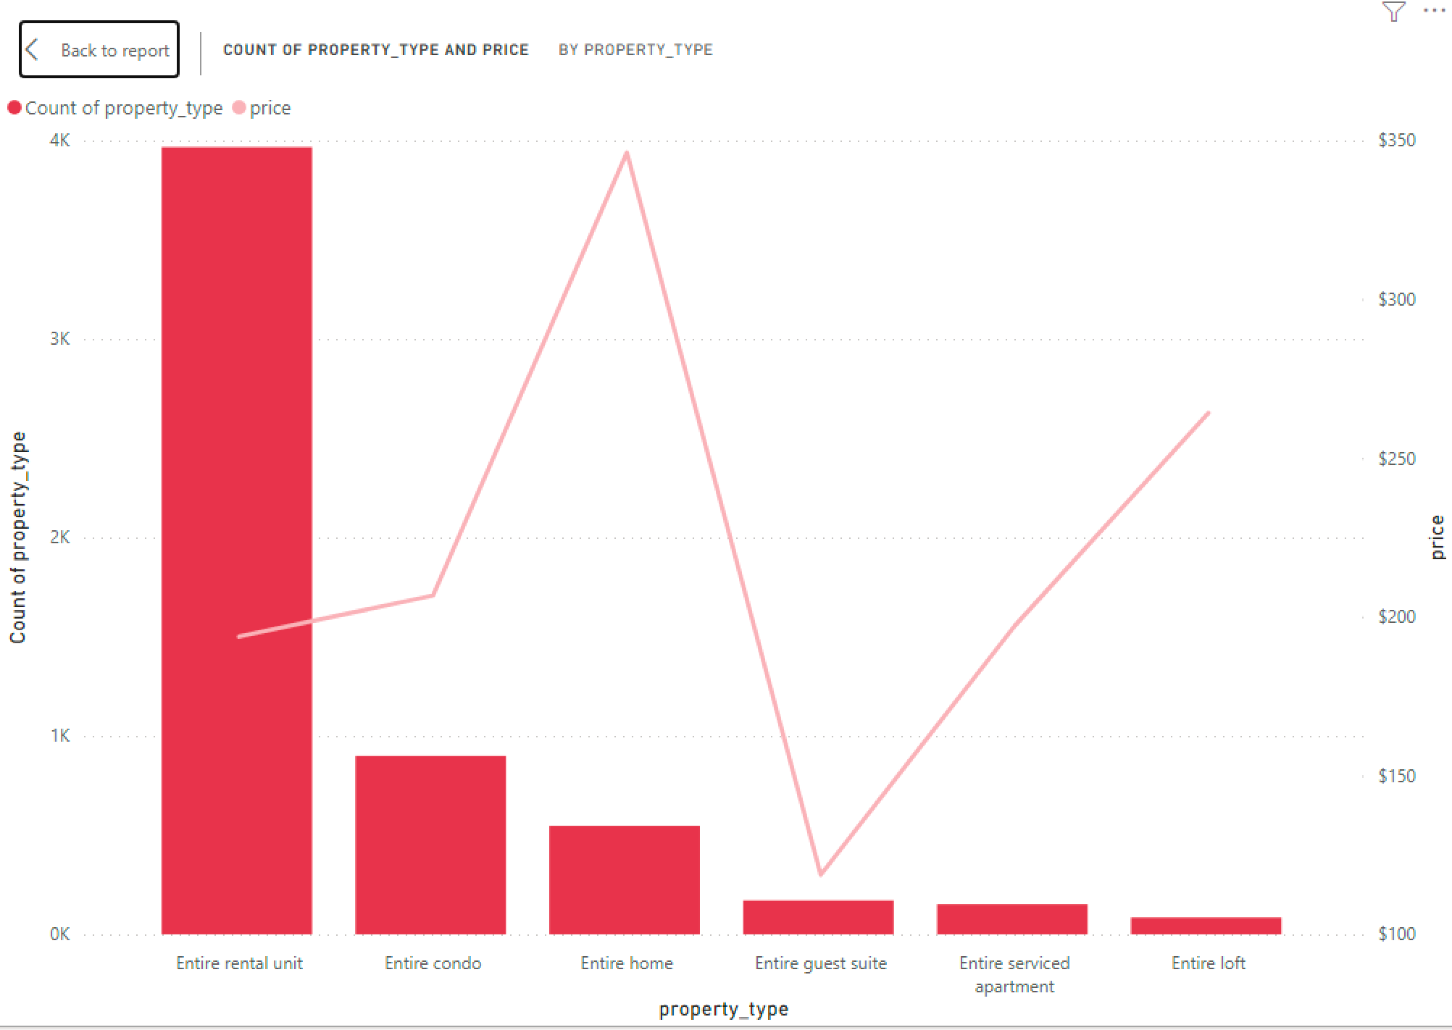

**Property and Listing Analysis**

We created a visualization to see the property prices based on the review count and listing by property type, room type, and over the months.

**Number of listings per property category**

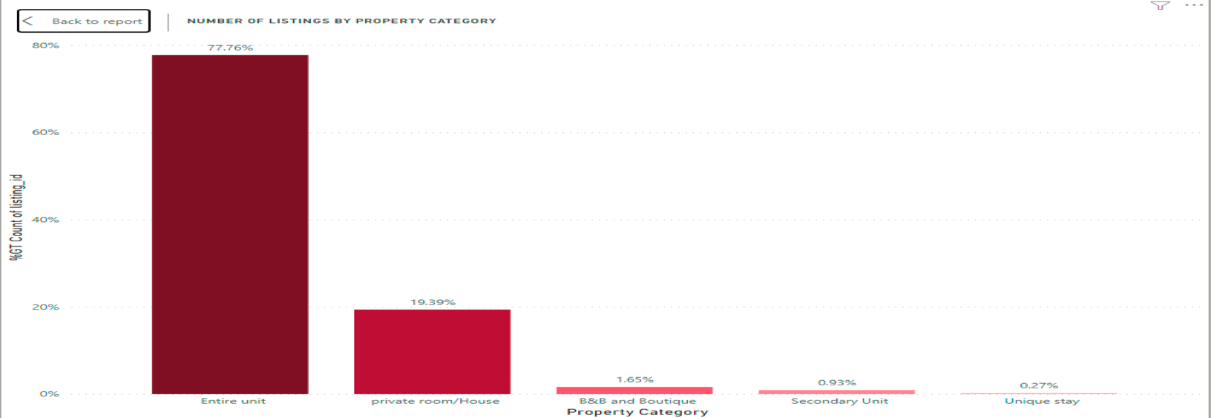

**Listings per month**

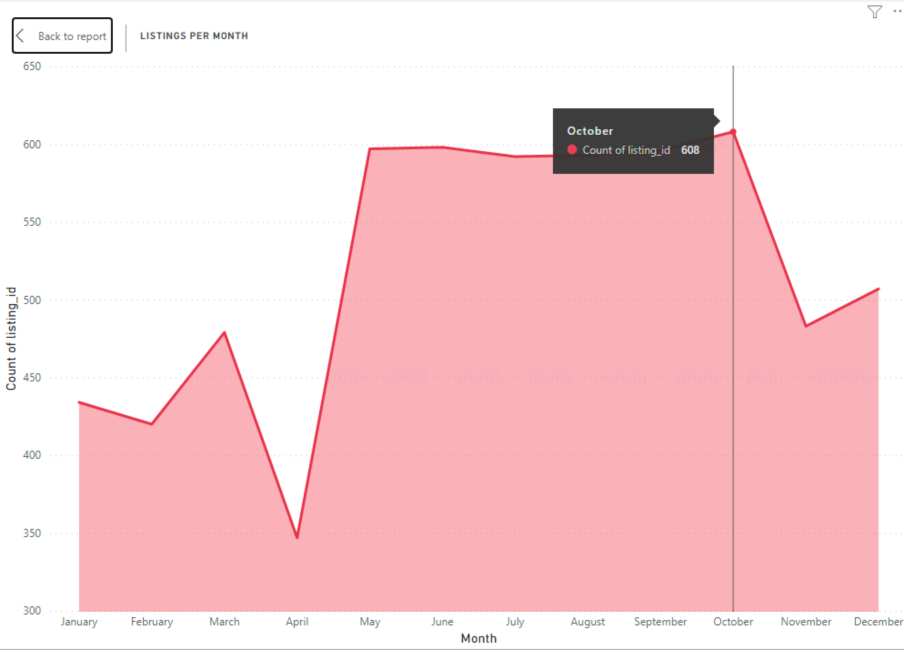

**Top 5 property prices and reviews**

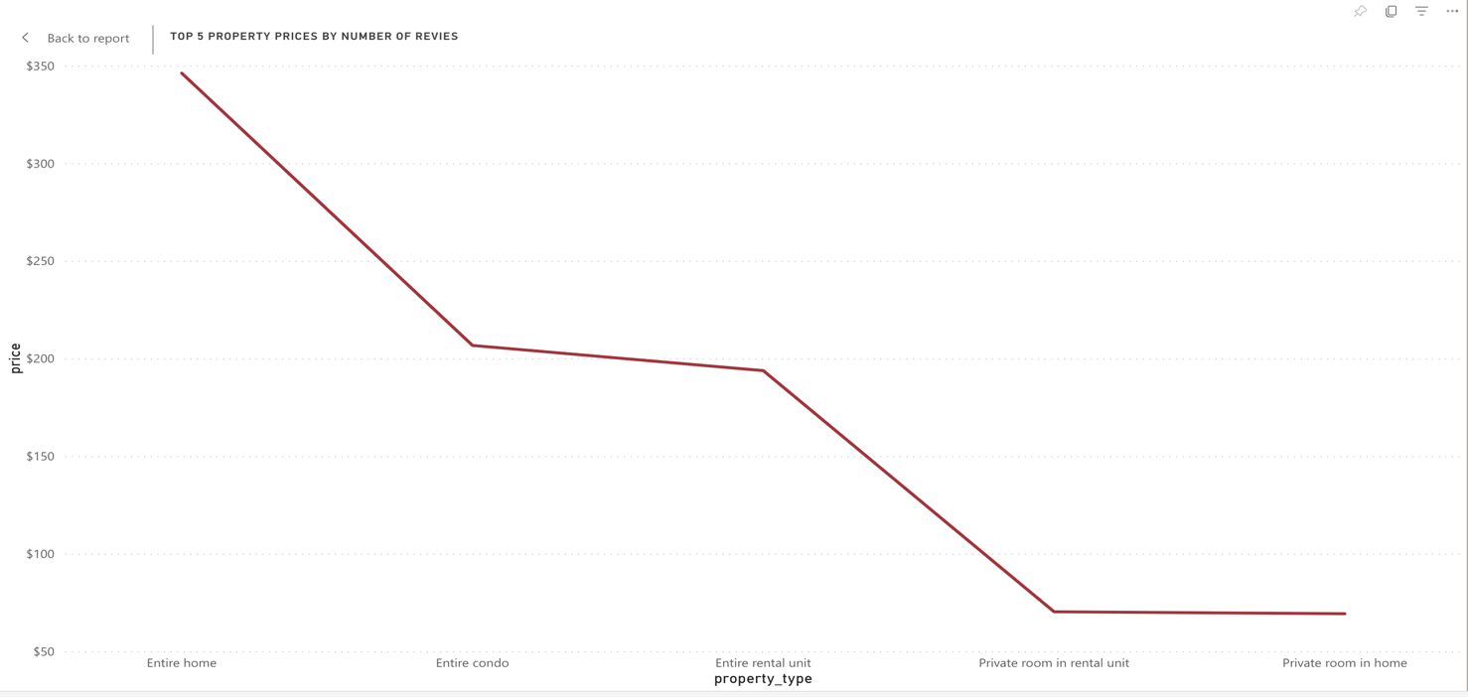

**Count of listings by room type**

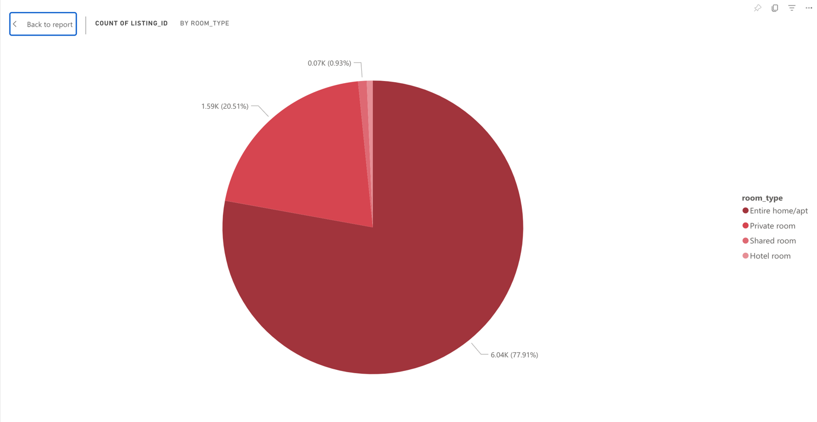

**Availability Analysis**

We wanted to know the Key influencers affecting the availability, along with each month's availability and total bookings.

**Key influencers for availability**

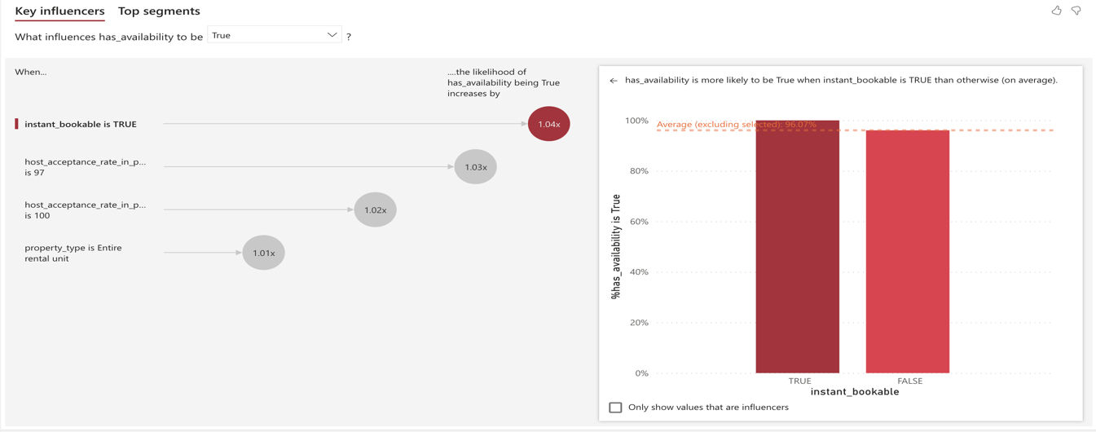

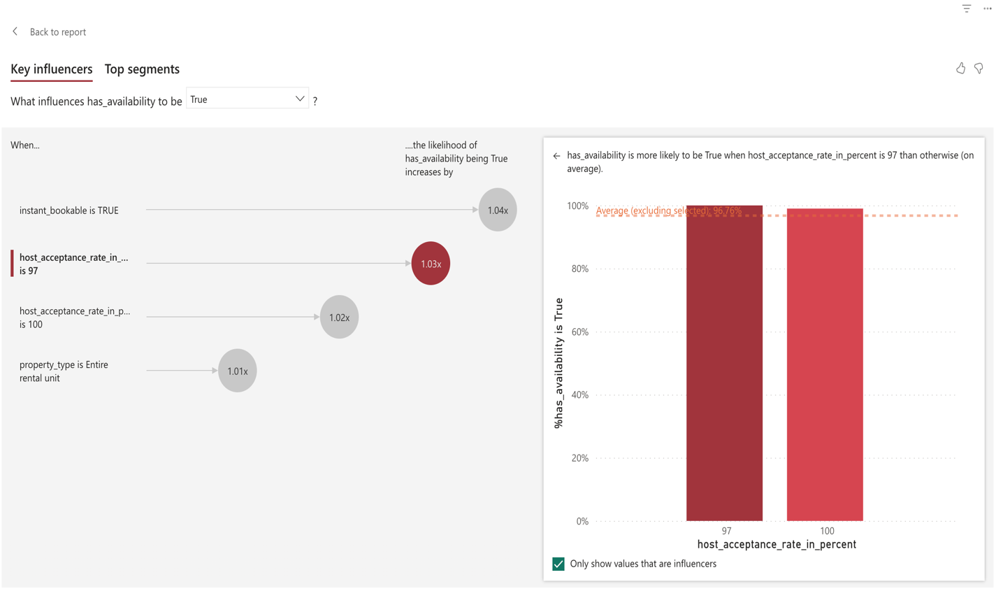

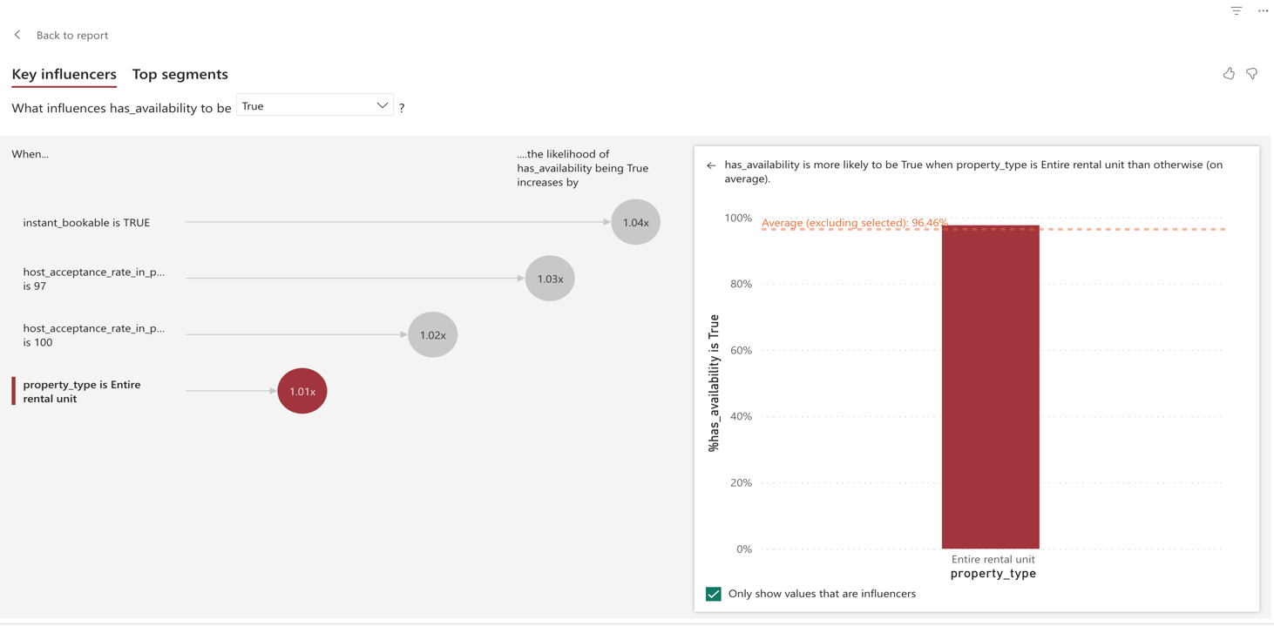

**Host Analysis**

In host analysis, we visualized the top 10 hosts with the highest listings and the number of reviews for each host.

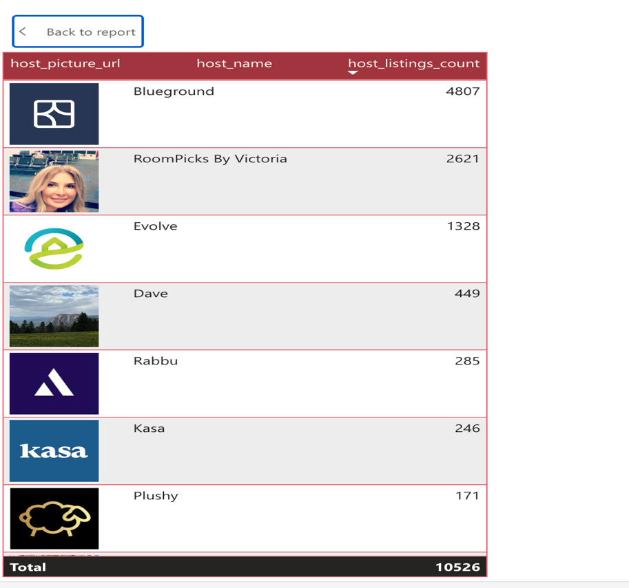

**Number of reviews and count of host response time**

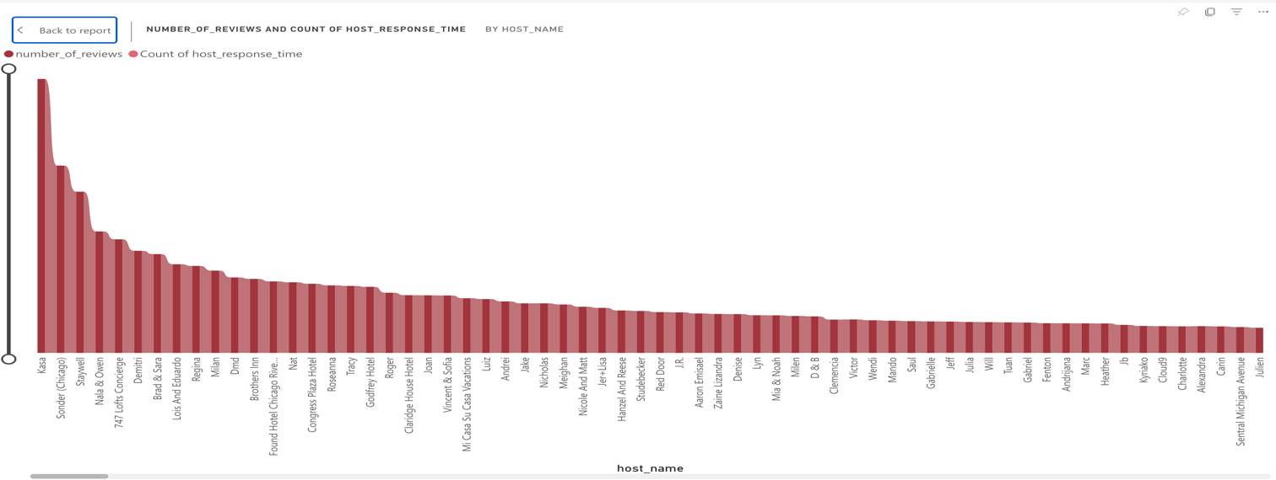

**Review Analysis**

We did sentiment analysis based on the customer reviews and visualized the top 10 locations based on review scores. We created a positive, negative, and neutral gauge chart based on the sentiment score.

**Top 10 Listings based on Reviews**

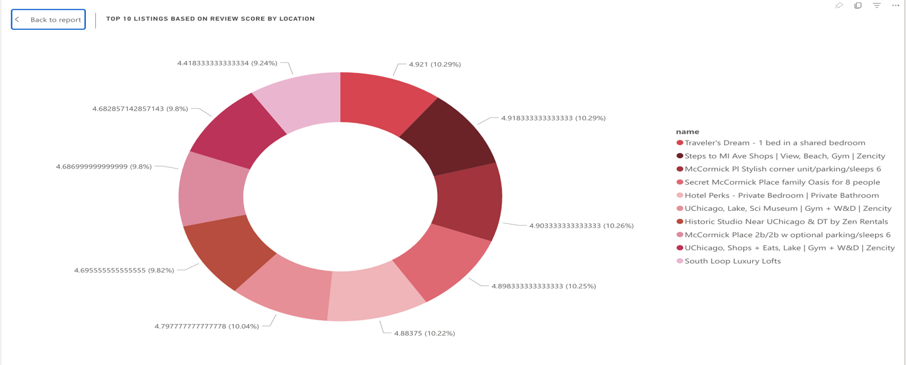

**Last 12 Month Reviews**

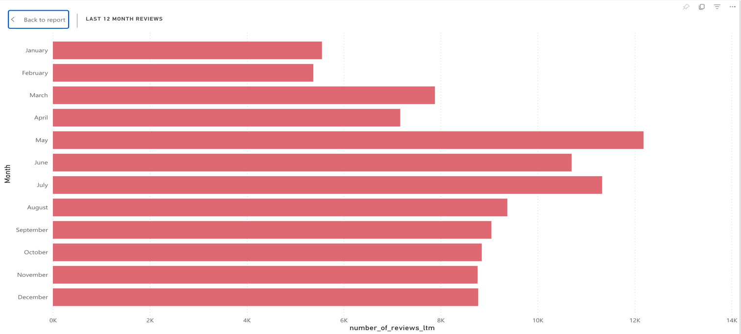

**Percentage based on sentiment score**

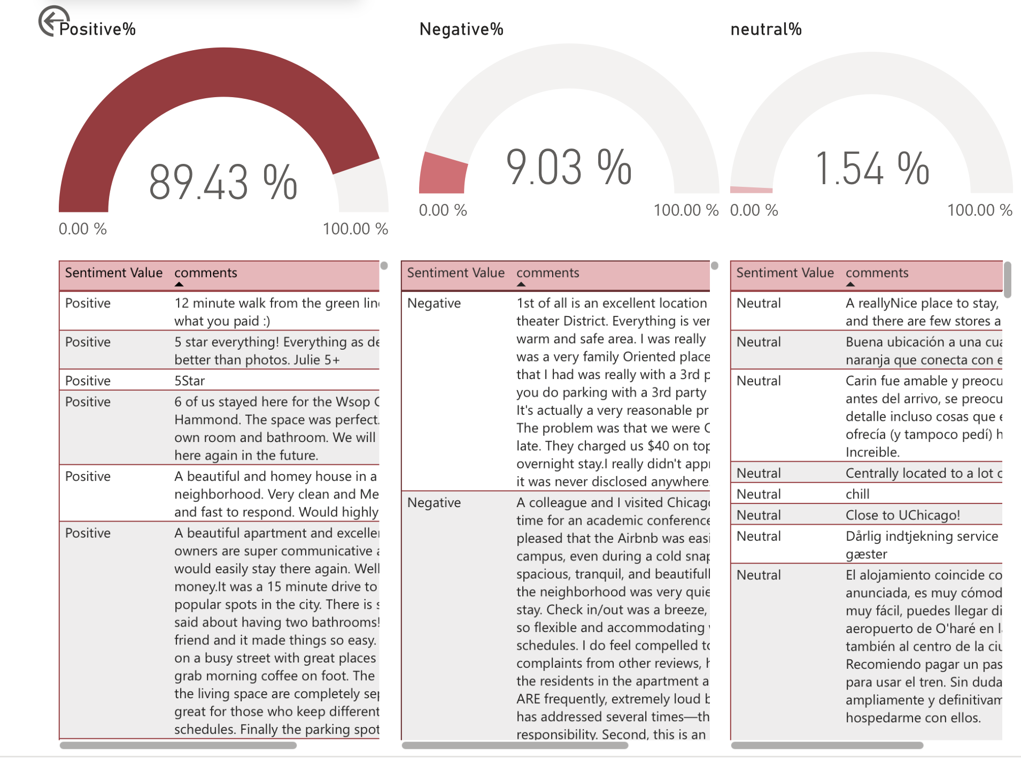

**Dashboard Design**

Here is the link to the dashboard report

<https://app.powerbi.com/groups/me/reports/ceffc957-82fe-49da-b3af-1b93a22aea9f/ReportSection37f969cf102e7334c884>

**Price Analysis Dashboard**

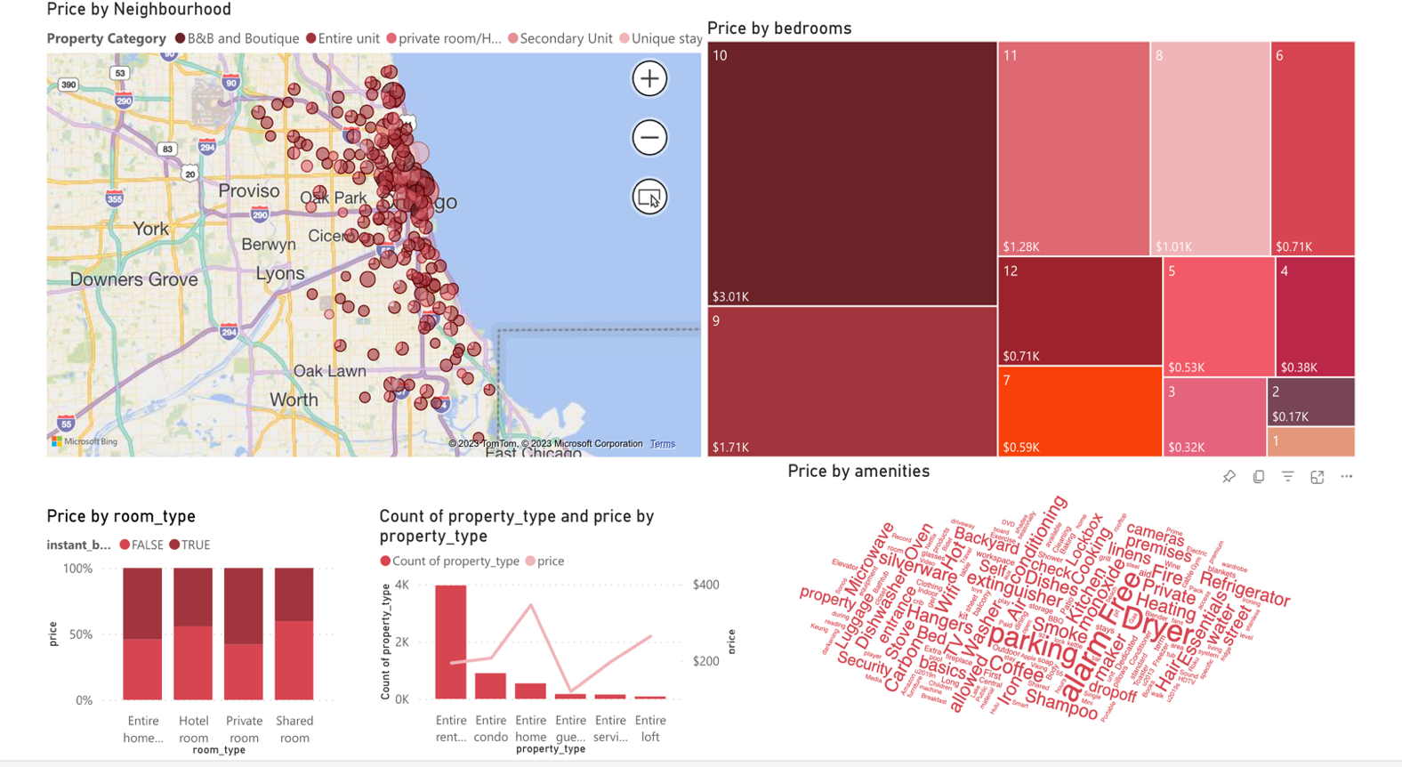

**Property & Listings Dashboard**

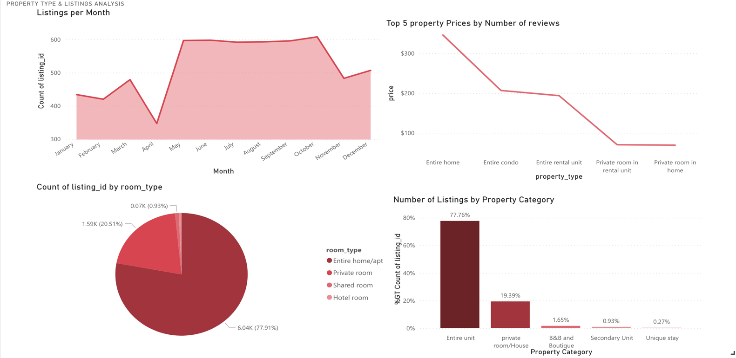

**Availability Dashboard**

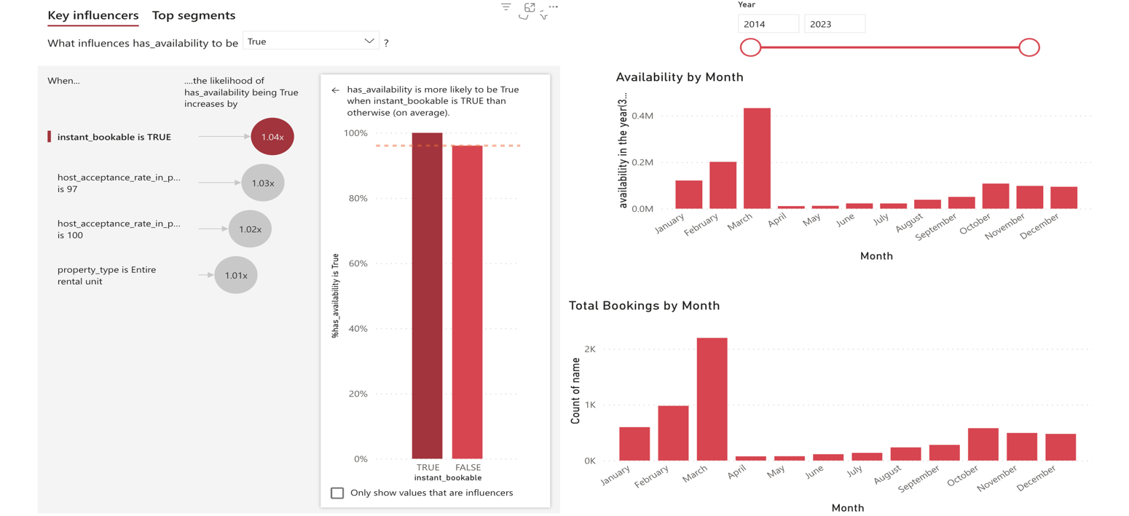

**Review Analysis Dashboard**

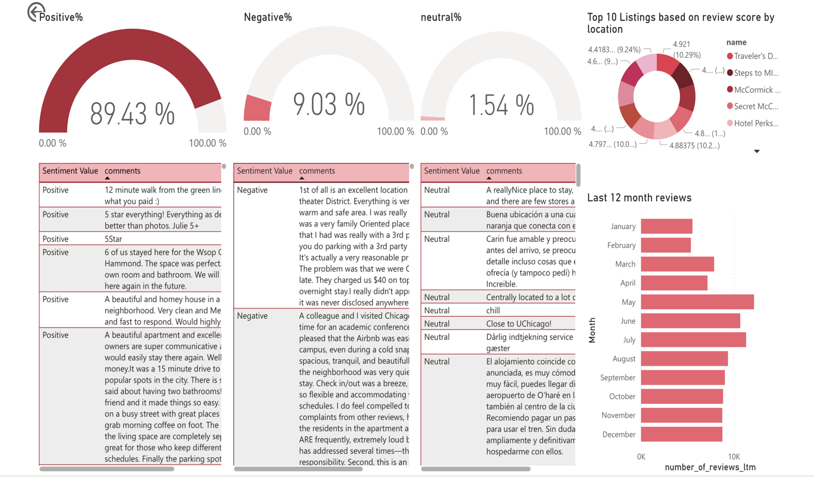

**Host Analysis Dashboard**

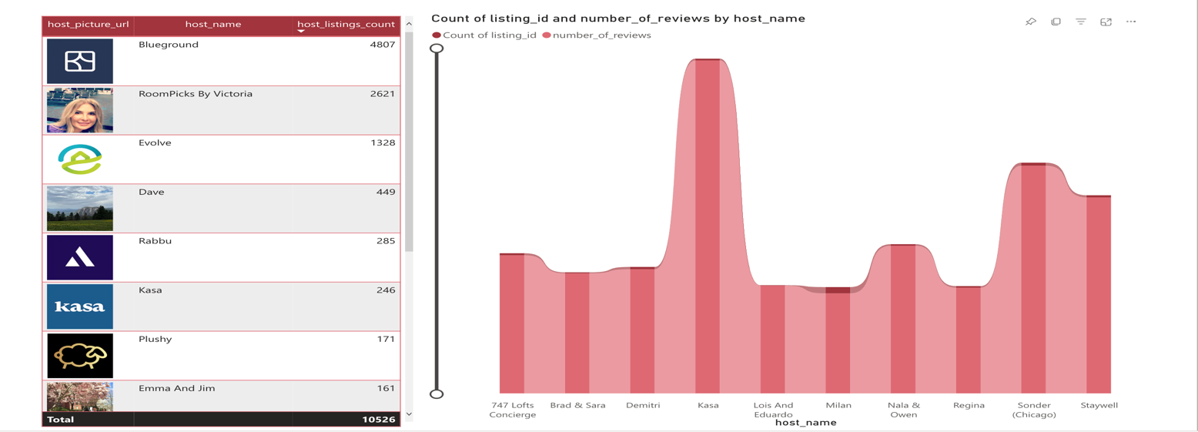

**Decomposition Tree**

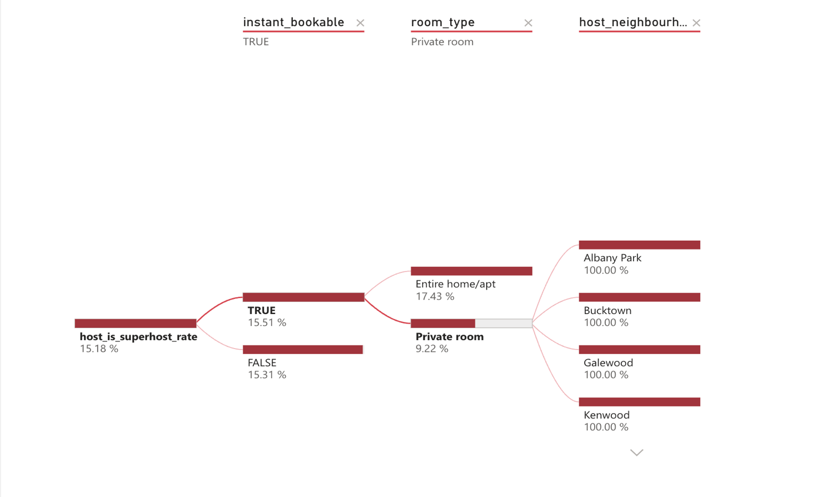

**Teach Q&A and Smart Narrative**

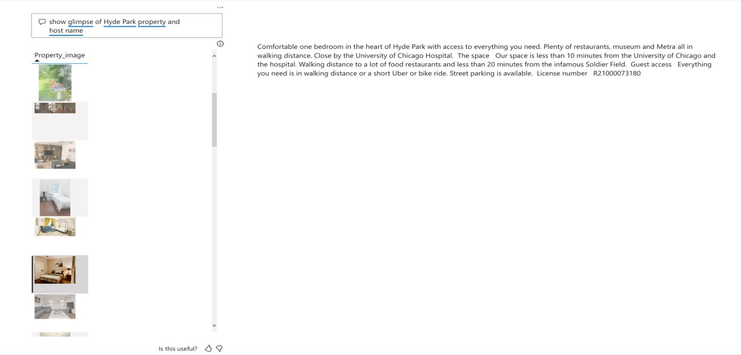

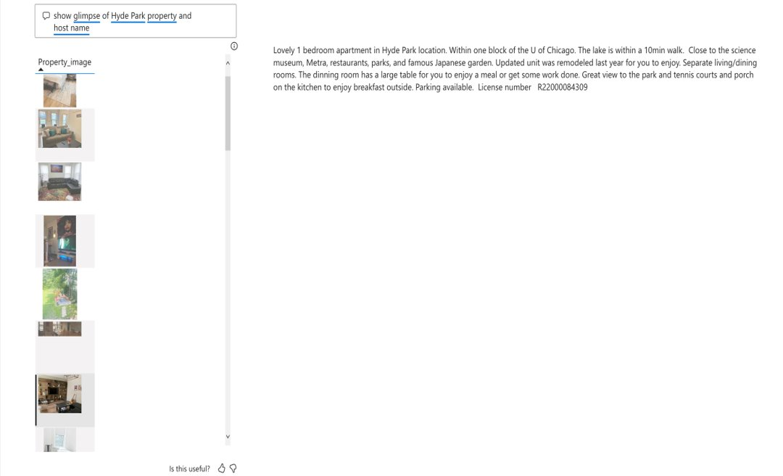

**Data Patterns & Recommendations**

In Chicago, most property types are Entire Apartments/houses least are unique stays. The property with 10 Bedrooms is higher than with 11-12 bedrooms. October has the highest listings, and the Entire Unit is leading in costs, reviews, and listings. The availability of listing is more likely authentic when it is Instantly bookable, the host acceptance rate is 97%, 100%, and the property type is the entire rental unit. Host Blue Ground has the highest listings, followed by Room picks from Victoria. As the host response rate increases, the number of reviews increases. 97.59% of reviews are optimistic about the Chicago listings, and Traveler's Dream is the top listing as per the location review score.

As per our analysis of the listings in Chicago, we recommend that if the host response rate is reasonable, the reviews are positive, and people are looking for instantly bookable properties.